How Does It Work?

A stepper motor is a motor that moves one step at a time, with its step defined by a step angle.

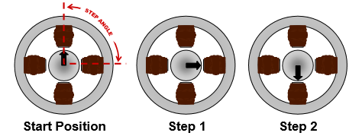

<http://www.microchip.com/stellent/groups/SiteComm_sg/documents/DeviceDoc/en543047.pdf>

The image above represents a stepper motor that requires 4 steps to complete a 360 degrees rotation. This determines the step angle to be 90 degrees.

The main components of a stepper motor are represented in the image below, and they consist of stators, windings(phases), and rotor.

The part that moves, is the rotor, which can be magnetized or not, depending on the type of stepper motor.

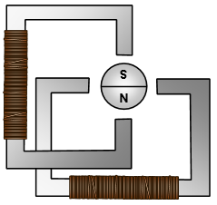

<http://www.microchip.com/stellent/groups/SiteComm_sg/documents/DeviceDoc/en543047.pdf>

By applying a voltage across one of the windings, current will start flowing through it. By using the right-hand rule, the direction of the magnetic flux can be determined. This is represented in the image below.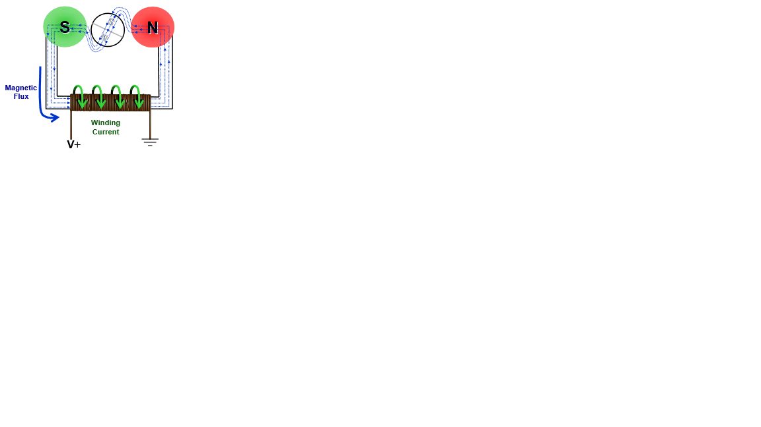

<http://www.microchip.com/stellent/groups/SiteComm_sg/documents/DeviceDoc/en543047.pdf>

The flux will want to travel through the path that has the least resistance. This determines the rotor to change its position to minimize resistance. This is shown in the image below.

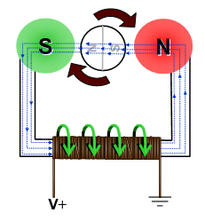<http://www.microchip.com/stellent/groups/SiteComm_sg/documents/DeviceDoc/en543047.pdf>

Types of Stepper Motors

Permanent Magnet Motor

This type of stepper motor has a magnetized rotor. Each winding, will be subdivided into two, to better understand how to motor functions. The image below represents the windings, and how they are distributed inside a stepper motor.

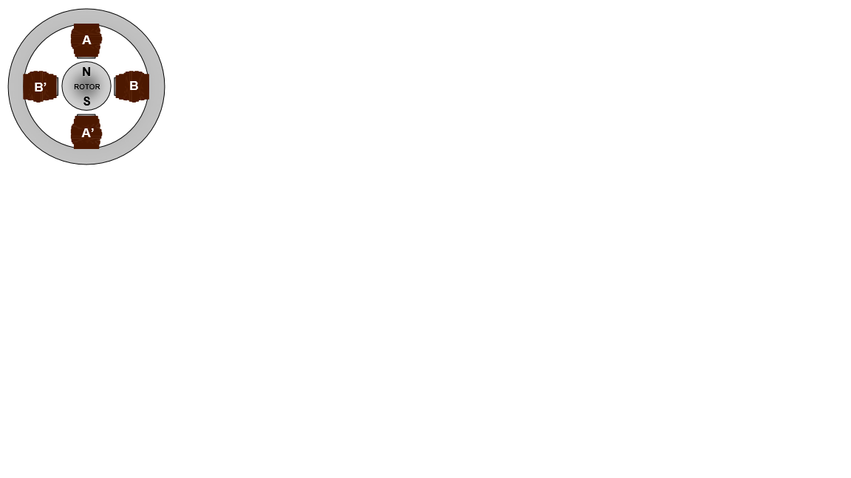 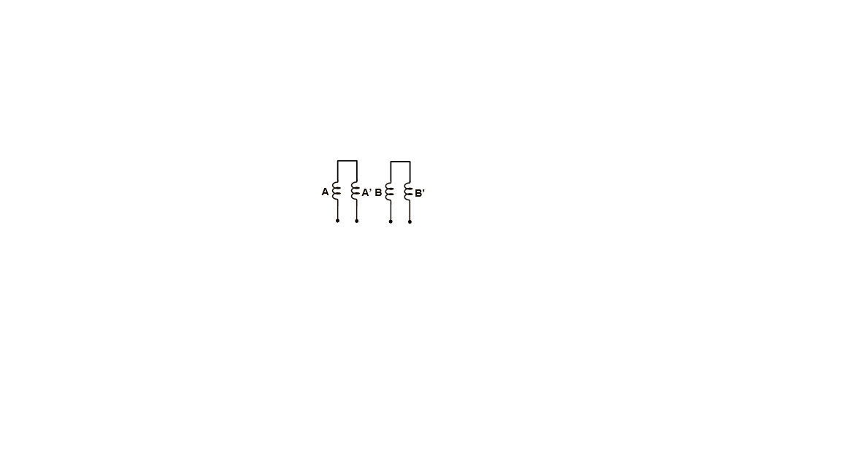

<http://www.microchip.com/stellent/groups/SiteComm_sg/documents/DeviceDoc/en543047.pdf>

The resolution of the motor can be improved in two ways, either by increasing the number of pole pairs in the rotor itself, or by increasing the number of phases as shown below.

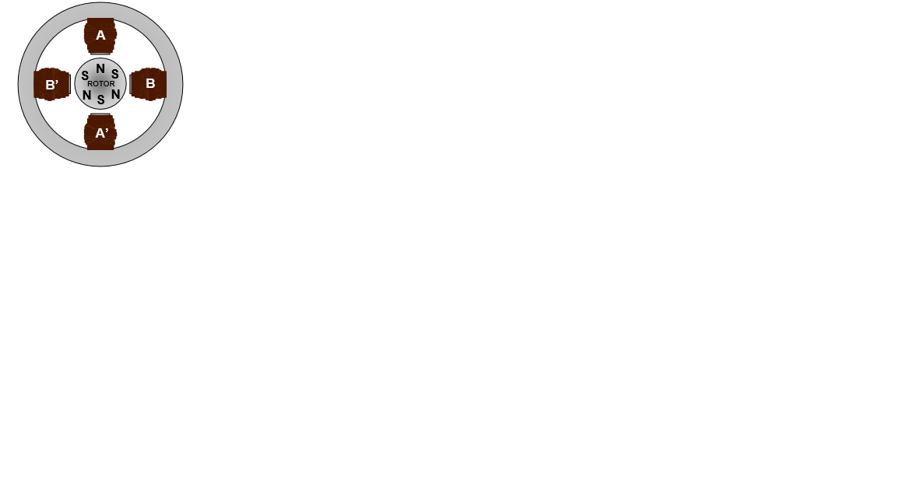 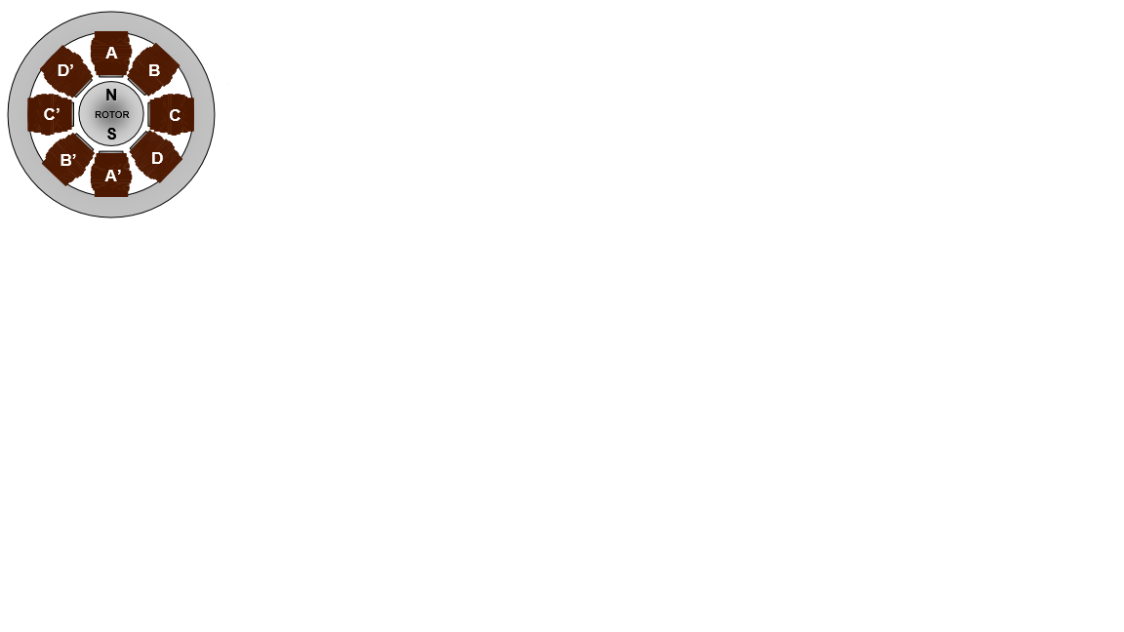

<http://www.microchip.com/stellent/groups/SiteComm_sg/documents/DeviceDoc/en543047.pdf>

To rotate the motor, simply apply a voltage across the windings in a sequence. A full rotation is shown in the images below, with the corresponding phase energized.

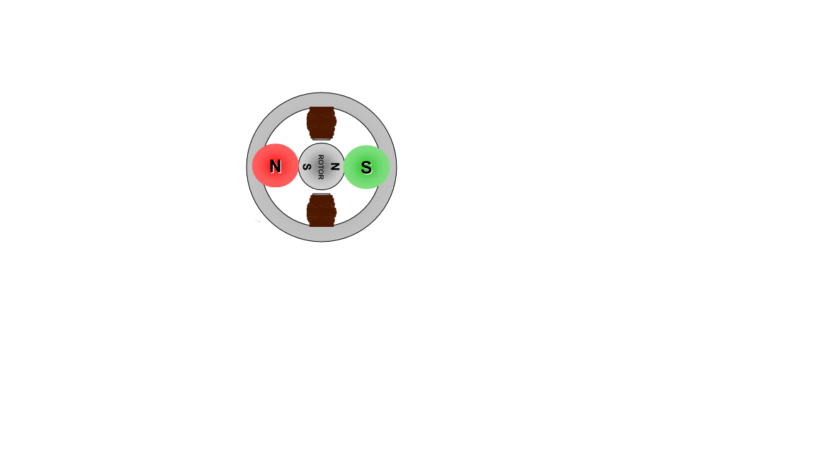 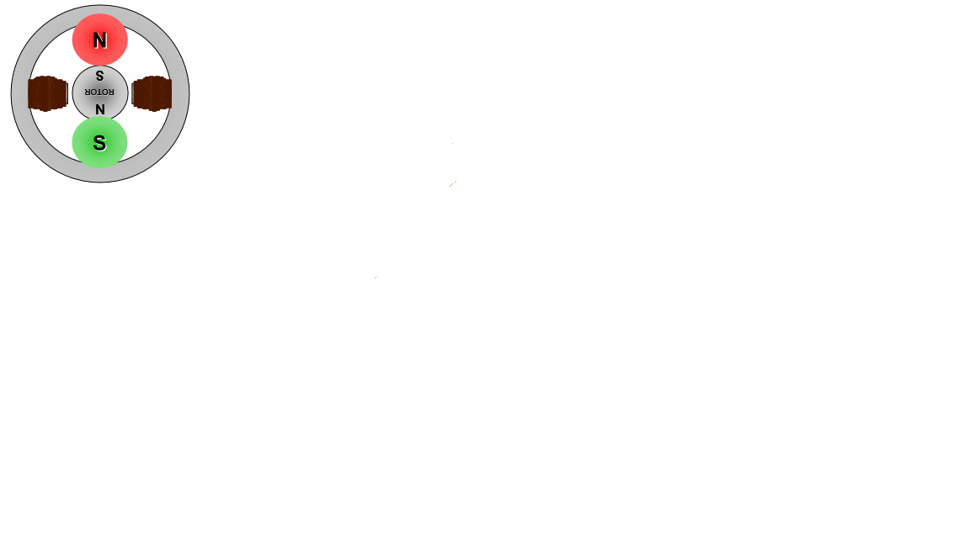 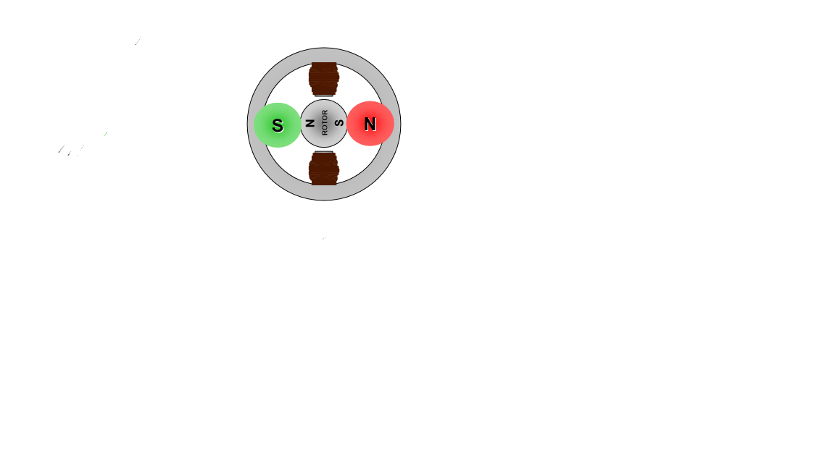 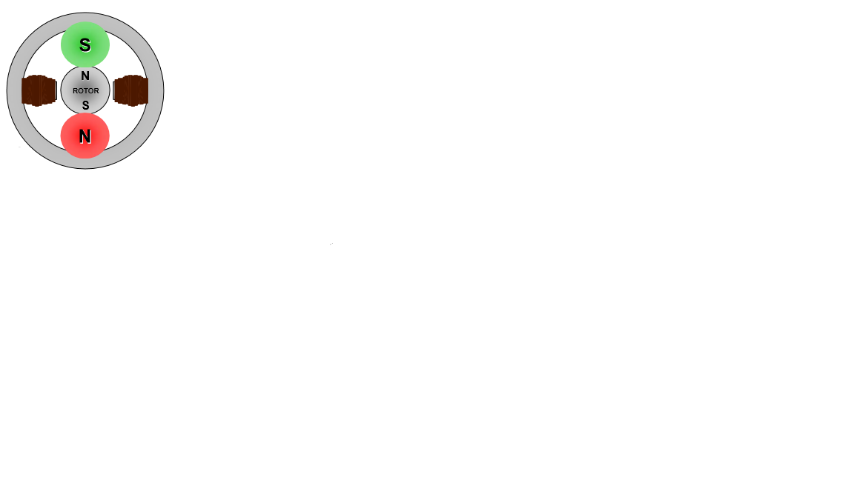

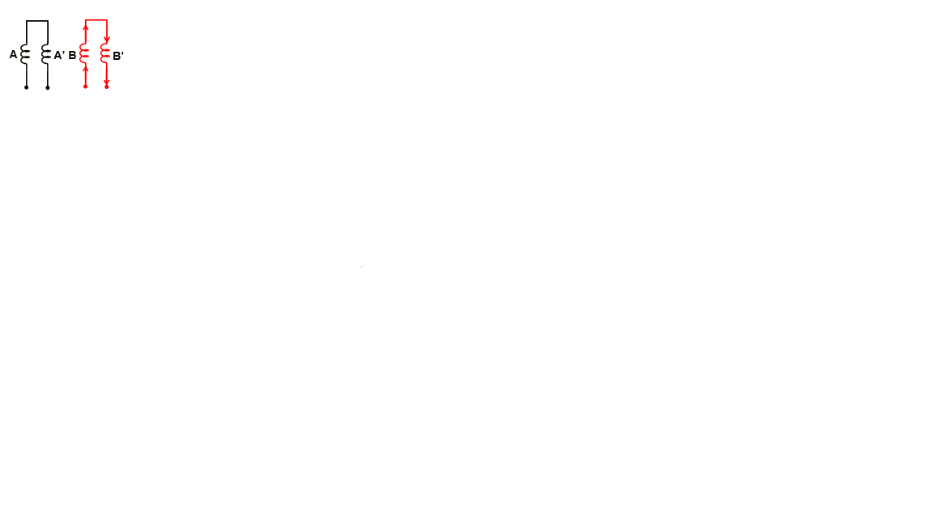 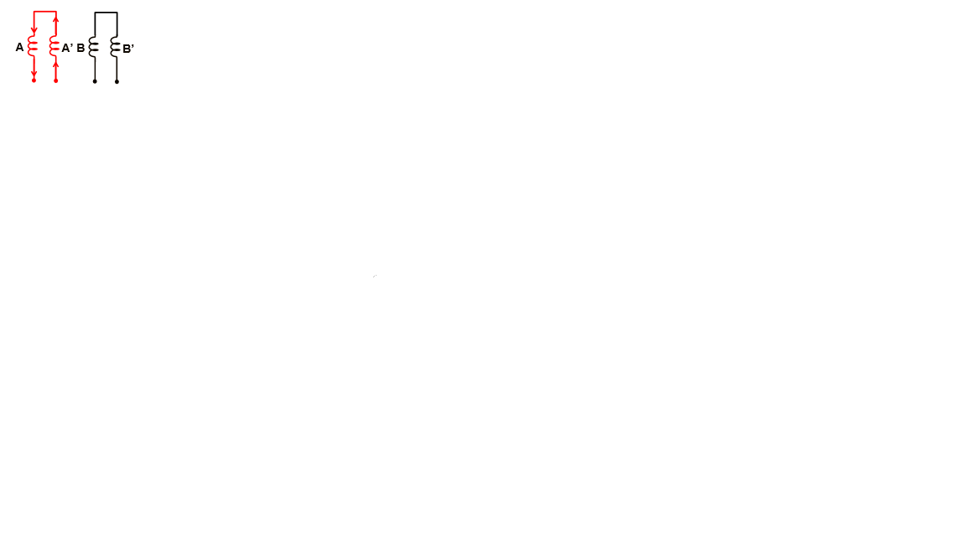 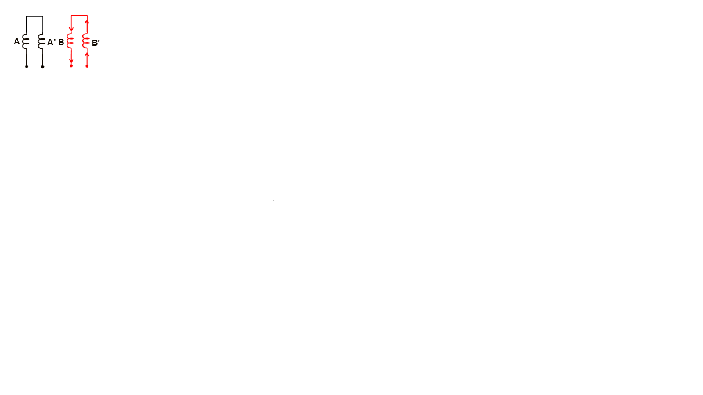 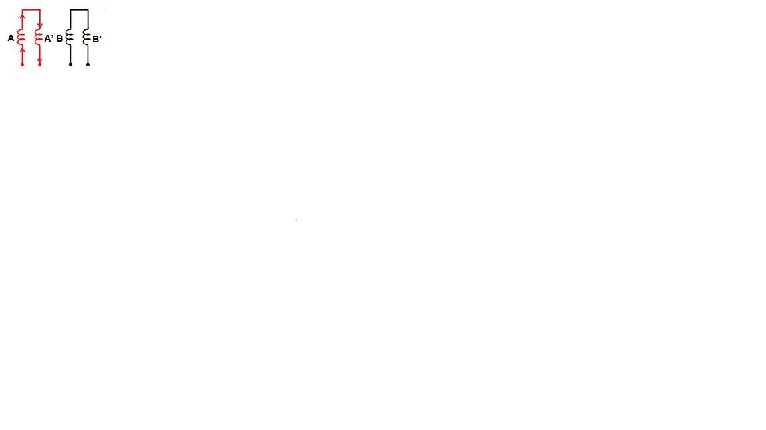

Variable Reluctance Motor

This type of motor, uses a rotor that is not magnetized, and has a number of teeth as seen in the image below. The winding are configured differently, as depicted in the second figure, all having a common voltage source but with each end being separate. They usually have 3 or 5 windings. Greater precision can be achieved by adding more teeth to the rotor.

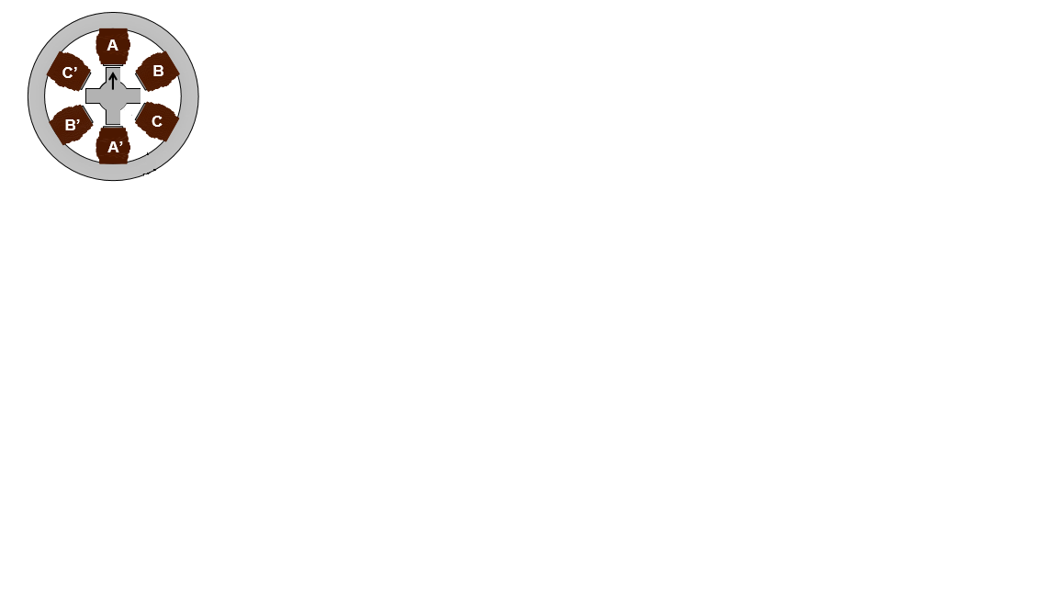 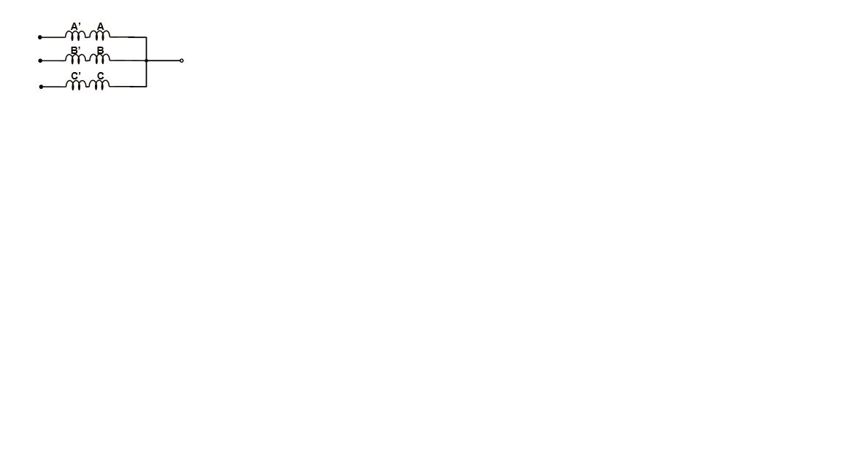

To spin the motor, each winding is energized one at a time, and the rotor rotates in such a way, to minimize reluctance. Some of the differences, between this type of stepper motor and the permanent magnet motor, are that, in order to spin the motor in a direction, the windings have to be energized in a reverse sequence, as depicted in the images below. In addition, the step angle is actually half of the one of a permanent magnet motor with the sam number of windings is.

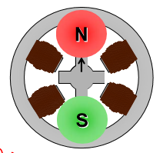 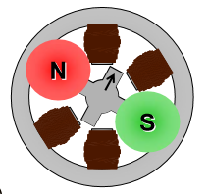

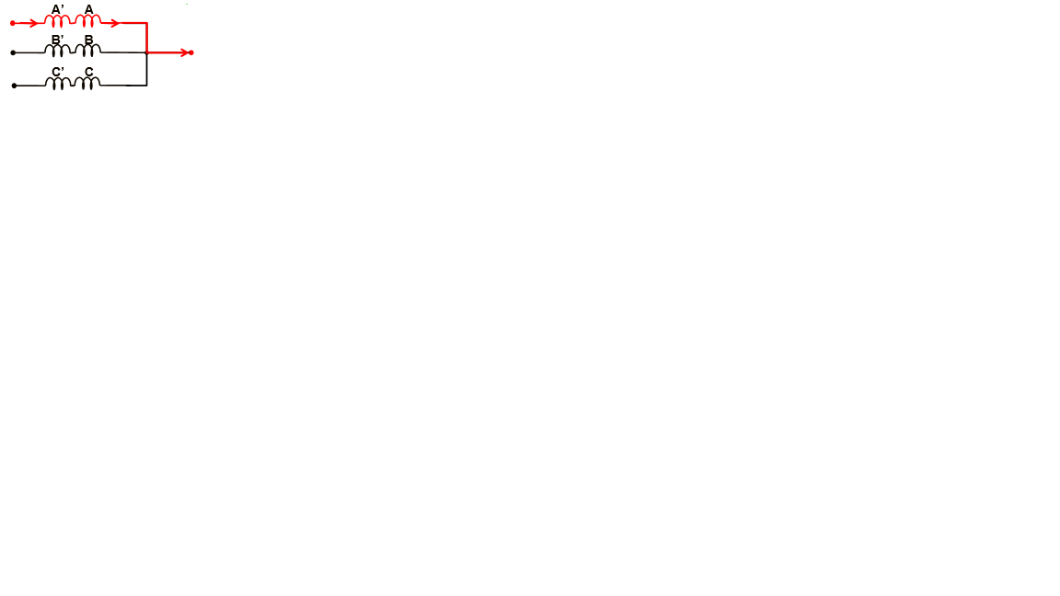 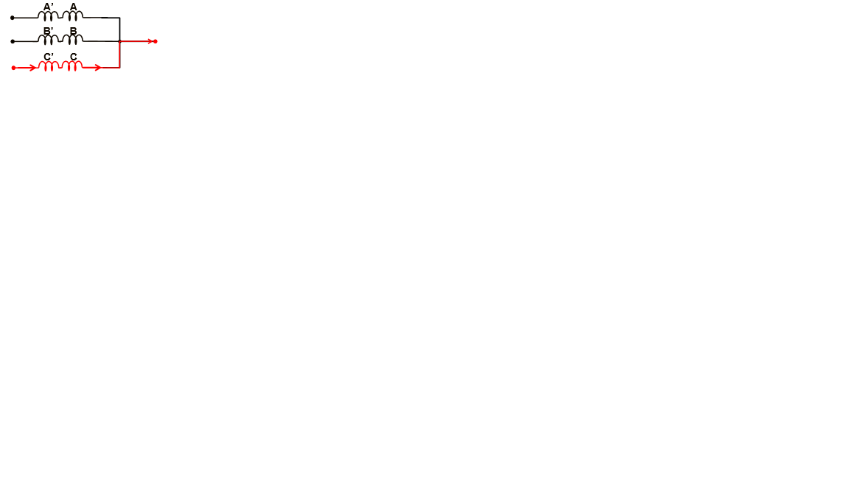

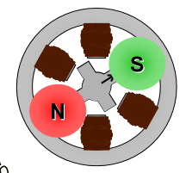 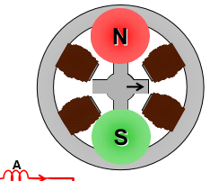

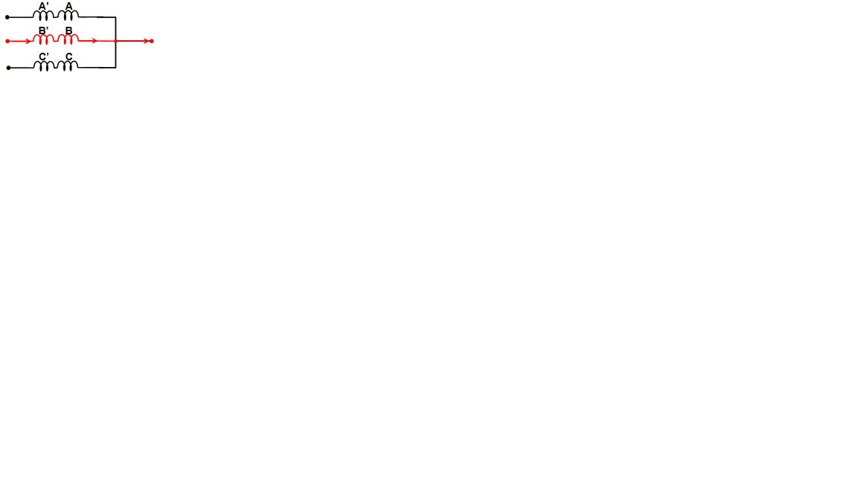 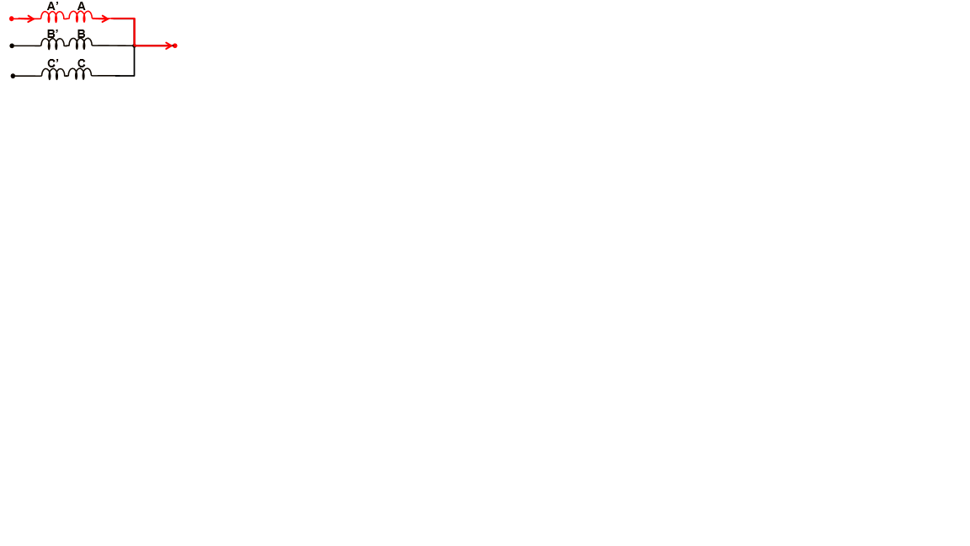

Hybrid Stepper Motor

Hybrid stepper motors borrow characteristics both the previous ones.

1. Stepper Motor
   1. How Does It Work
   2. Permanent Magnet/Variable Reluctance/Hybrid
   3. Unipolar and Bipolar
   4. Conclusion: (Bipolar Hybrid)
2. Stepper Motor Drive Board
3. Movement
   1. Stepping Methods
   2. Anti-Resonance
   3. Torque
4. Program
5. Wheel